# Parametric exploration in ParaPower – development philosophy

A single ParaPower simulation is defined through a select group of model execution parameters and a collection of geometric primitives (Features) with attached material, thermal, and discretization attributes.

A parametric study seeks to vary one or more of any of these fields in order to create a parametric space that contains multiple simulations, each with a different simulation outcome. What ParaPower should support is an intuitive way to describe the intended parametric space, a method for the user to instruct the program on the outcomes of interest (not just the full temperature field, for example), and a method of post-processing and visualizing the study results. An aspirational goal should be for the user to flexibly define how ParaPower should search within the space defined, allowing the tool to strategically choose values of free parameters to generate a response surface with sufficient resolution in areas of interest and lower resolution in uninteresting areas.

## Describing the parametric space

ParaPower supports implicit parametric definitions by using vector notation in any fields of the GUI except feature material assignment. Material properties of individual materials can, however, contain a vector notation definition. In a scripted setting, material assignment can be parametrized by inputting a cell array containing the material labels.

ParaPower also supports a parameter definition interface that allows for named parameters. Scalar parameters can be used to cleanly define a substitution rule that occurs in one or more fields, but do not on their own describe a parametric study. Named parameters with vector values, however, do prompt a parametric study, and are the explicit alternative to the inline vector definition described previously. In fact during the parametric analysis, the inline vectors are converted to independent (programmatically) named parameters for the purpose of post processing.

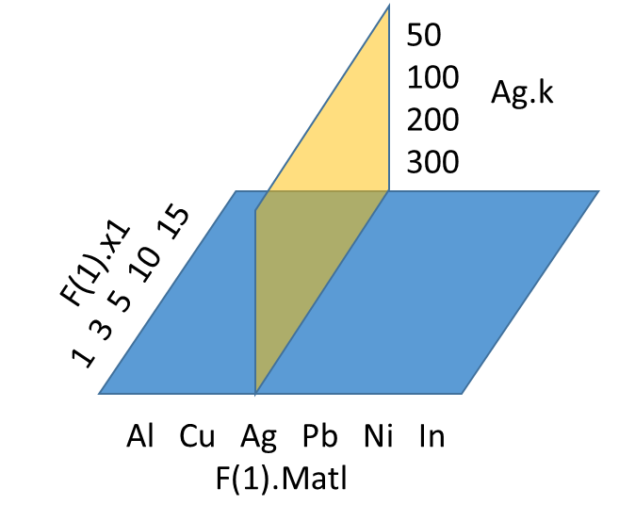

Current issues:

Named vector parameters create a new dimension even when not used in any fields or other parameter definitions

Similarly, parameterized material fields create dimensions even when that material is never used in model.

A derived parameter will eval to a vector and be treated as a new independent dimension when the intent is likely to perform a (parameterized) substitution that is not independent of the parent variable.

Parameterized Time steps/dt: Slider on GUI is locked to #of steps of case 1 and tooltip tip is also fixed to case 1. If other cases have less steps than case 1, requesting the last timestep (using slider) of that case leads to index exceeds error.

Implicit field parameterizations should be promoted to explicit parameters once programmatically named.

## Defining outcomes of interest – sensors

asdfkads

## Post-processing and Visualization

adsfkasdf

## Sparse Search, Adaptive Search, and Optimization

asdfasd